**Lab 04**

* Section 1.1: Step 11 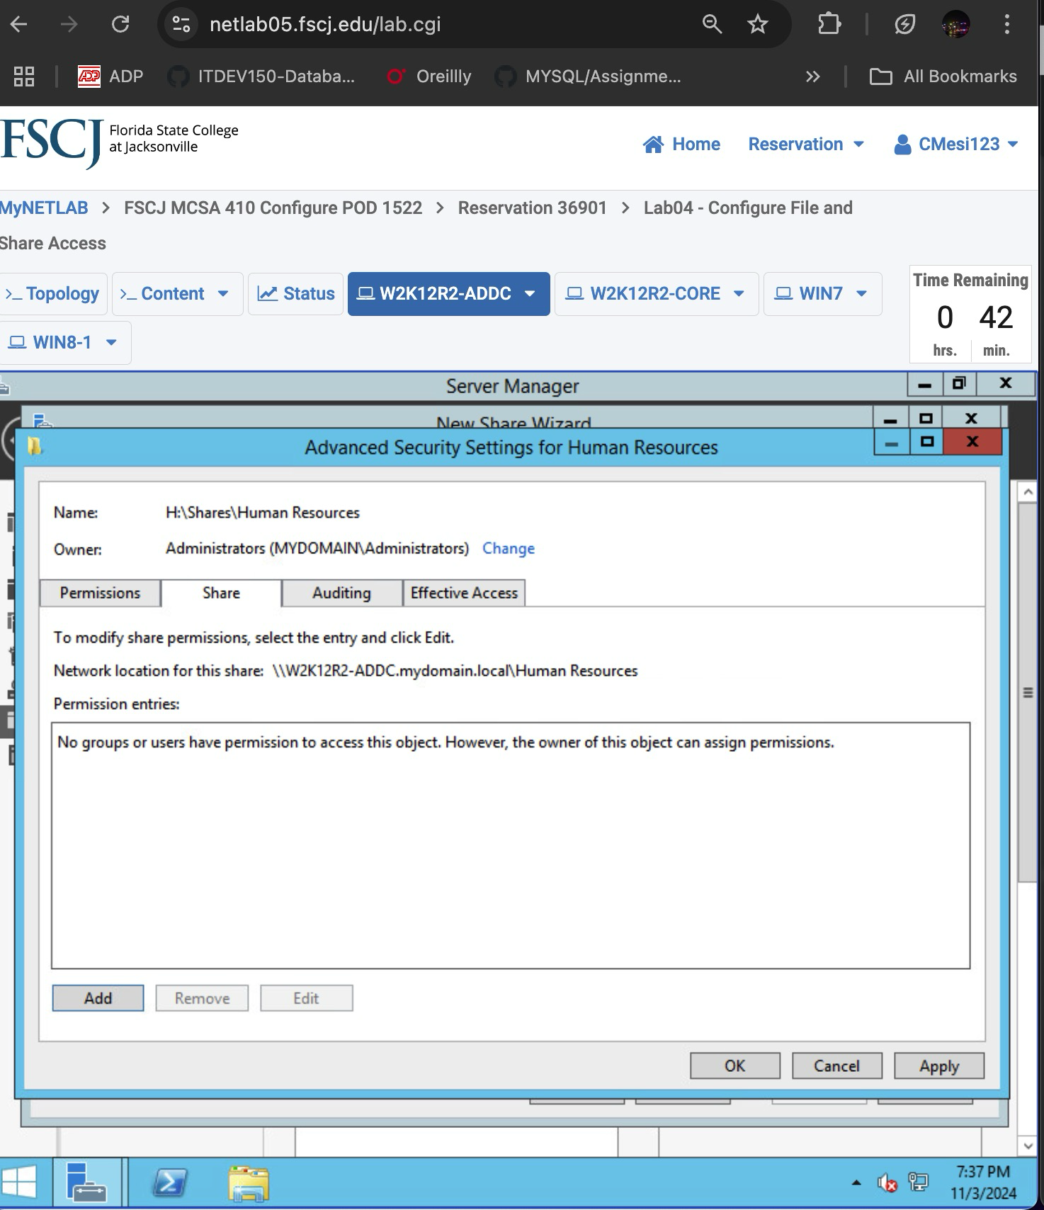
* Section 1.2: Step 7 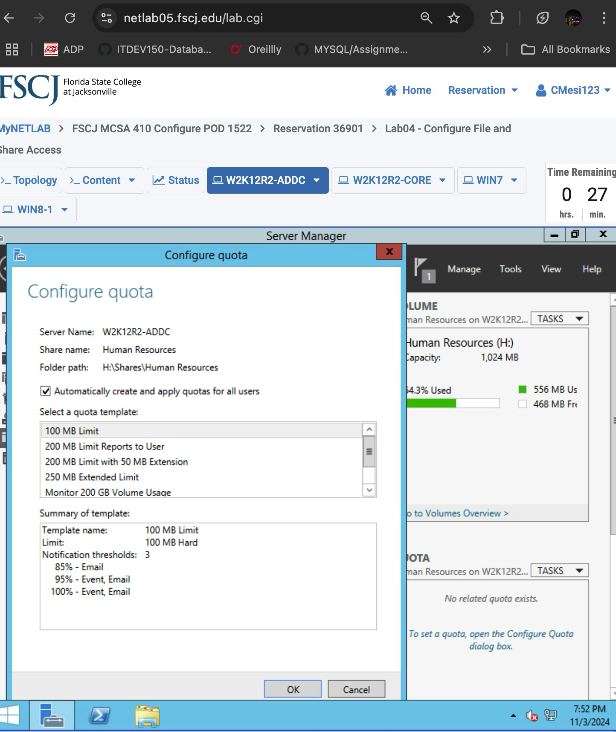
* Section 2.1: Step 11 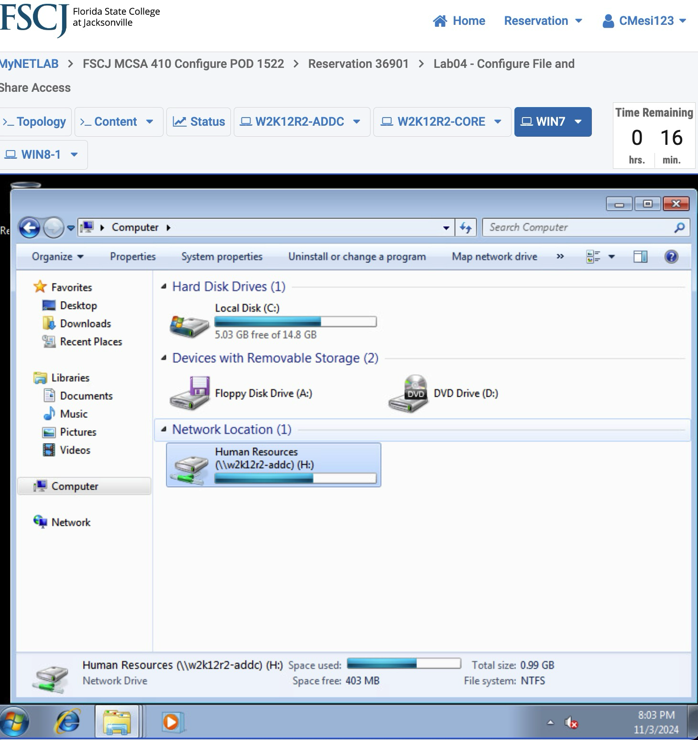
* Section 3.1: Steps 32 and 39 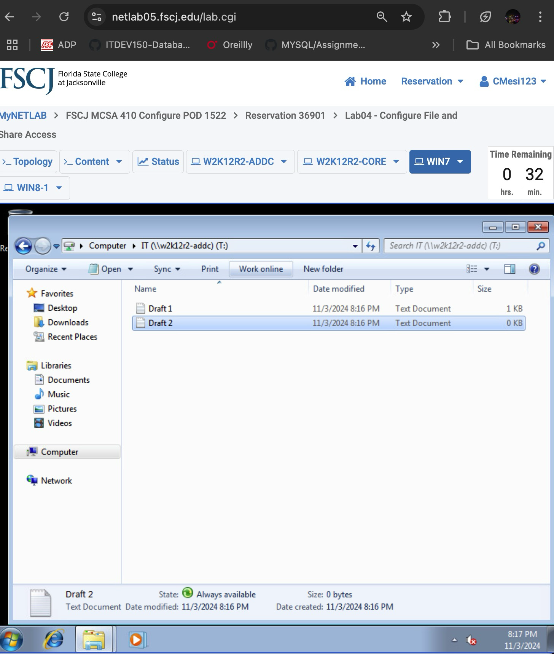  
    
  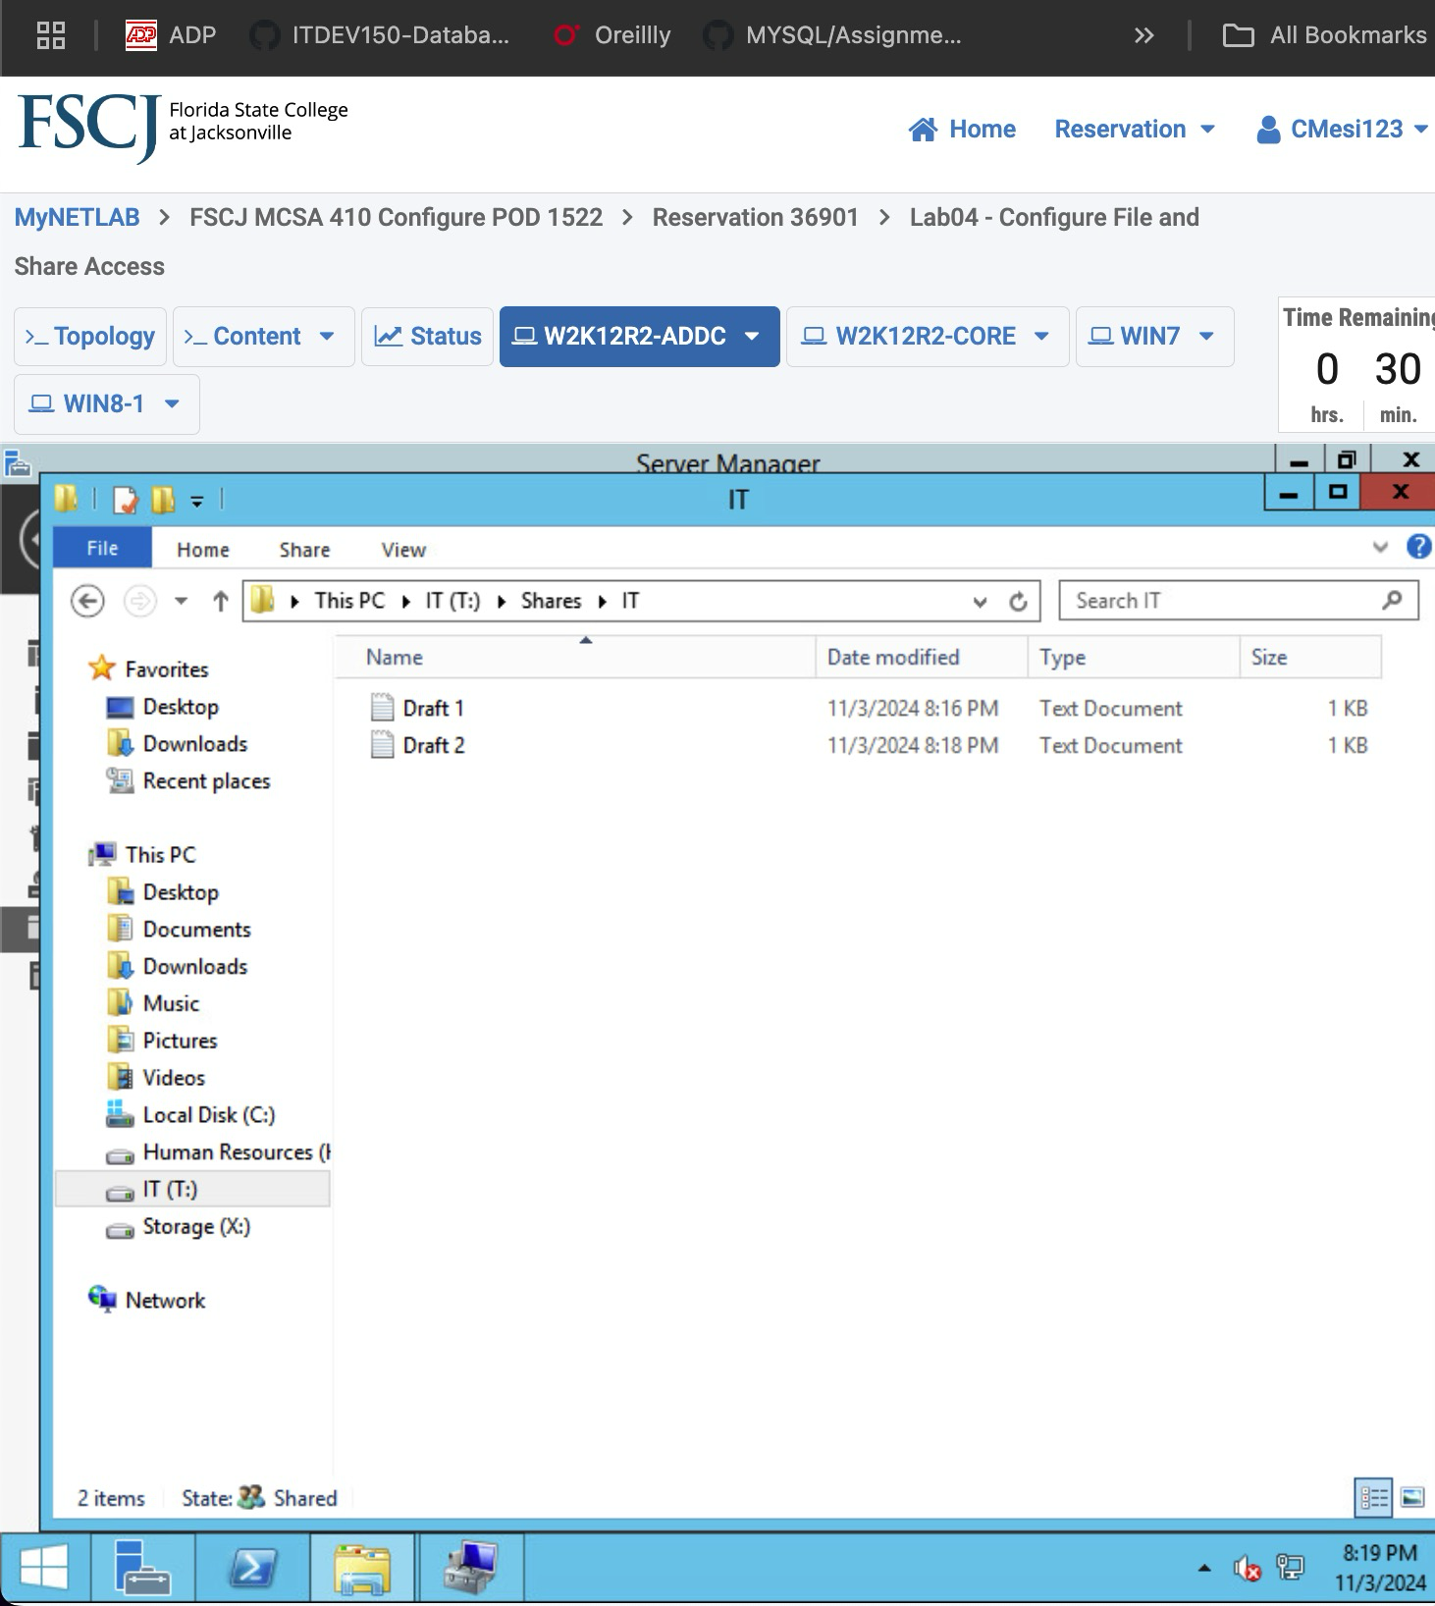

**Lab 18**

* Section 1.1: Step 23 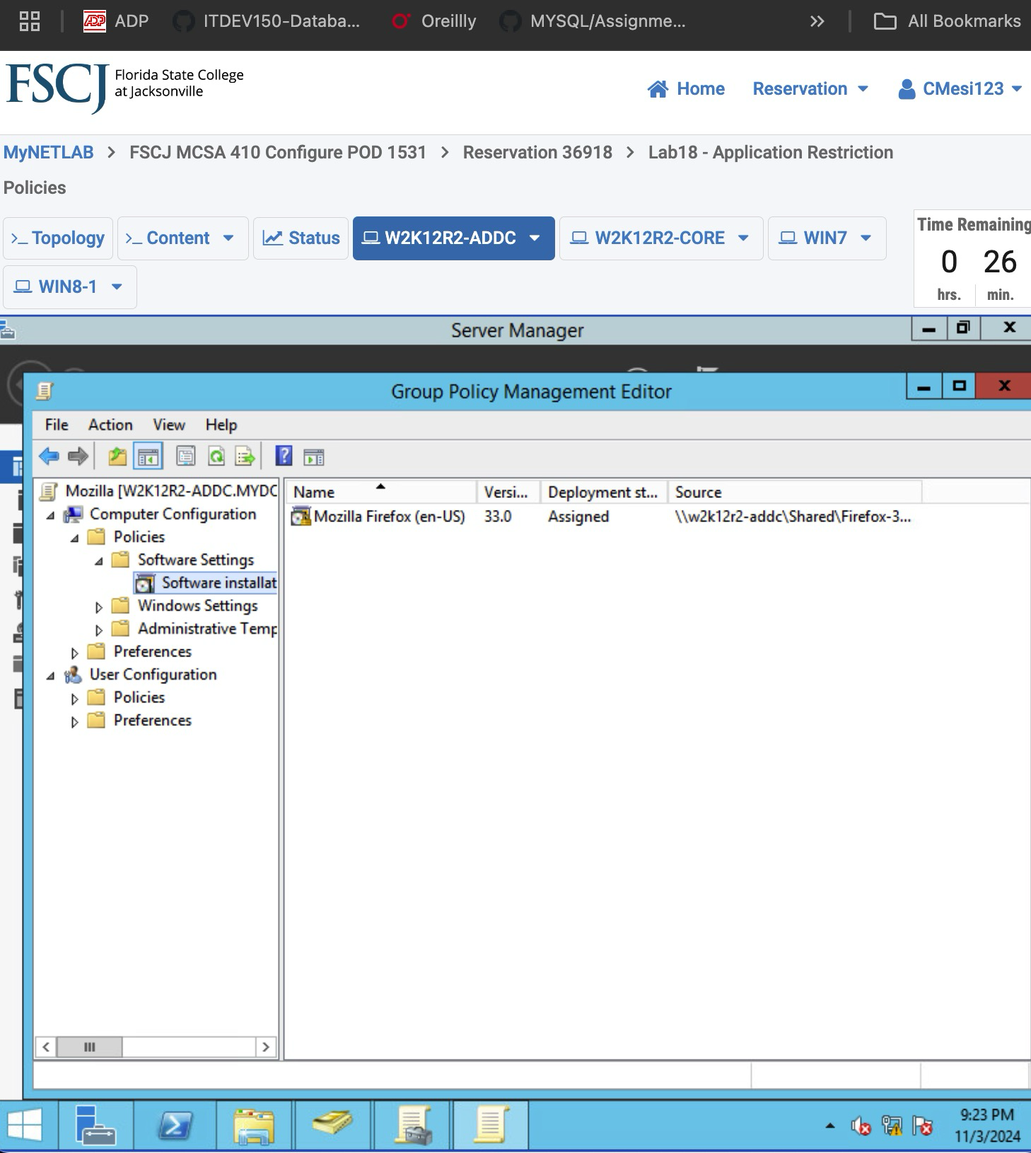
* Section 2.1: Step 14 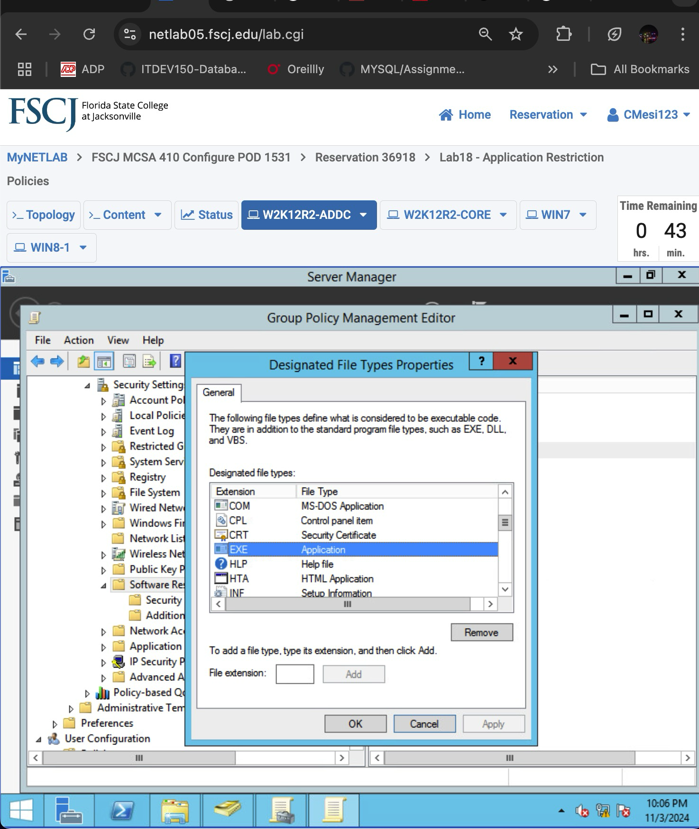
* Section 2.2: Step 8 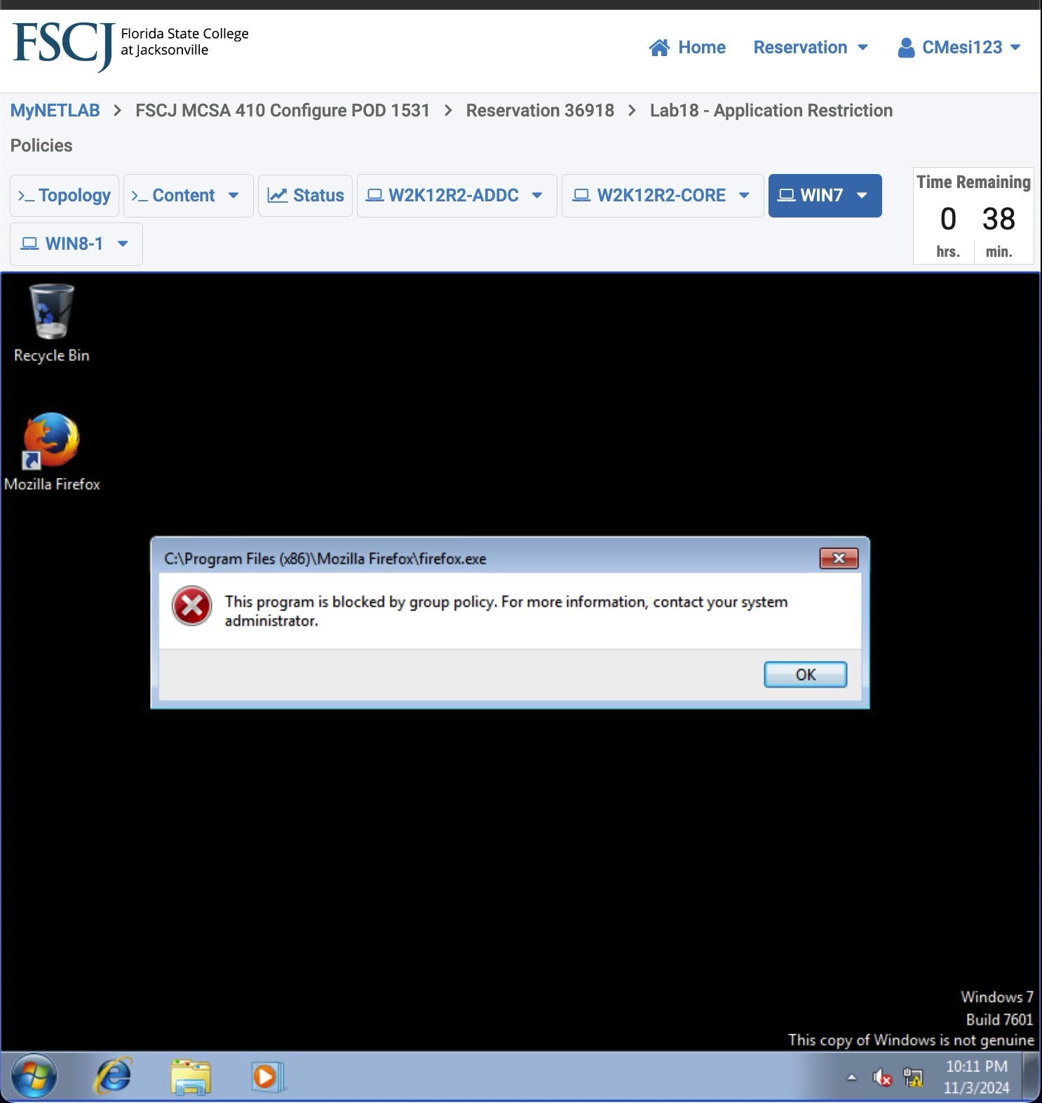
* Section 3.1: Step 7 